**SURF Meeting Minutes**

**Time and Date:** Monday, 18 October 2021

**Venue: Online**

**Members:** Yue Li (YL), Xingbo Wei (XW)

# Preparations

1. Questionnaire toolkit developing
   1. Developing the toolkit UI alpha version.

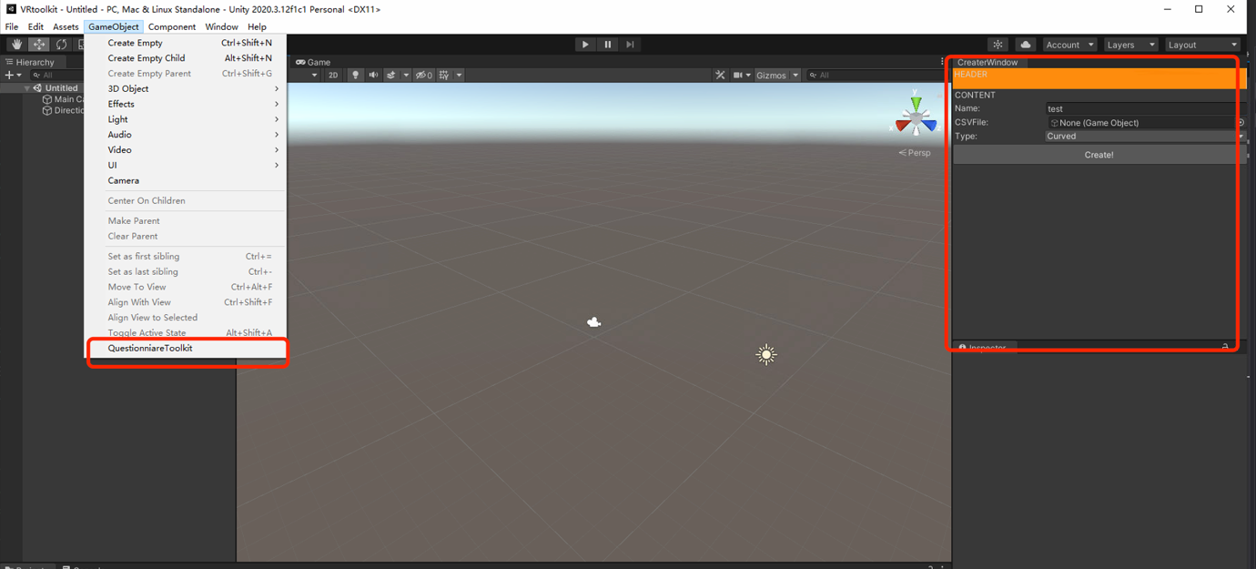

1. Recode the shooting VR demo gaming.
   1. Modify the player move way: user only use stick to control movement.
2. Paper-reading
   1. Measuring Presence
      1. IMMERSIVE TENDENCIES QUESTIONNAIRE (ITQ)
      2. SLATER-USOH-STEED QUESTIONNAIRE (SUS)
      3. Presence Questionnaire (PQ) (by Witmer and Singer)
      4. igroup presence questionnaire (IPQ)
   2. Interaction way:
      1. world-based anchoring and laser pointer interaction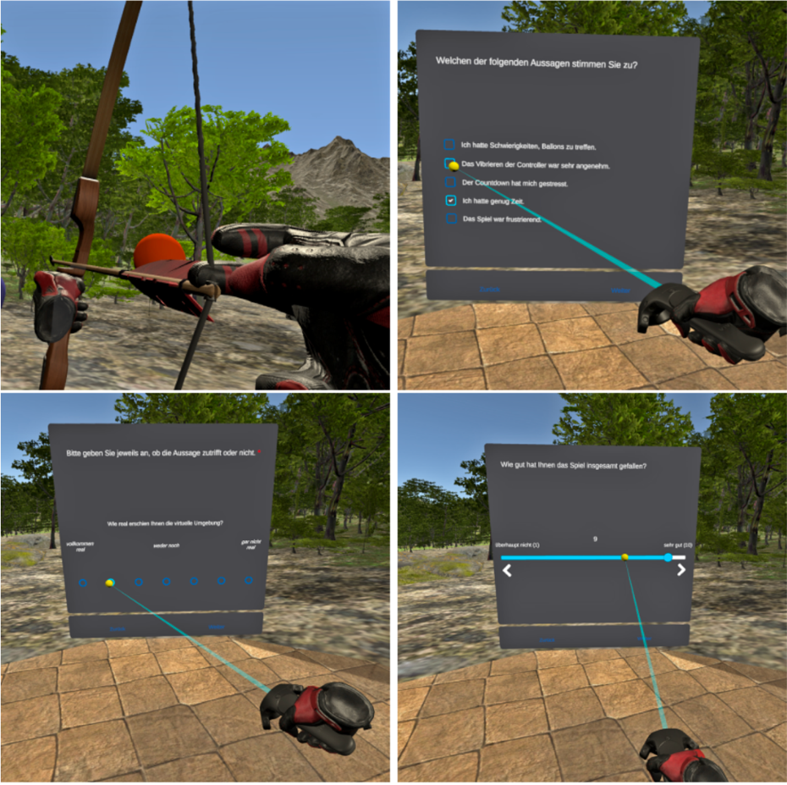
      2. In-experience questionnaires presented in a pop-up style and operated via the participants’ tracked hands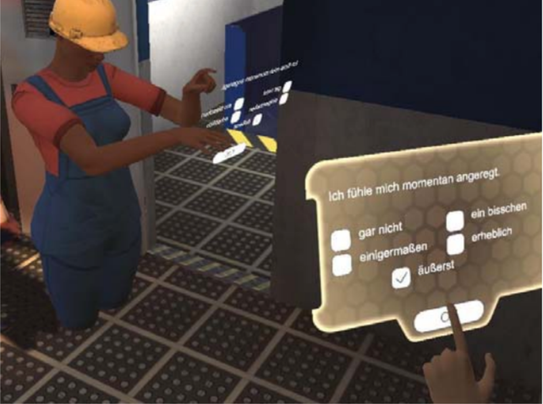
      3. varied the visual and auditory fidelity of the scenes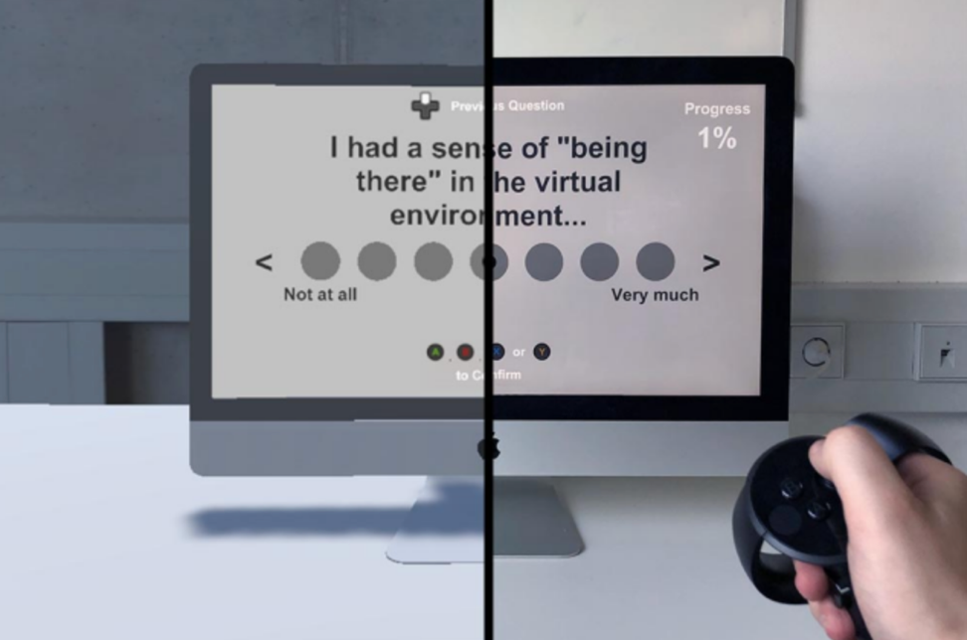
      4. NASA-TLX questionnaire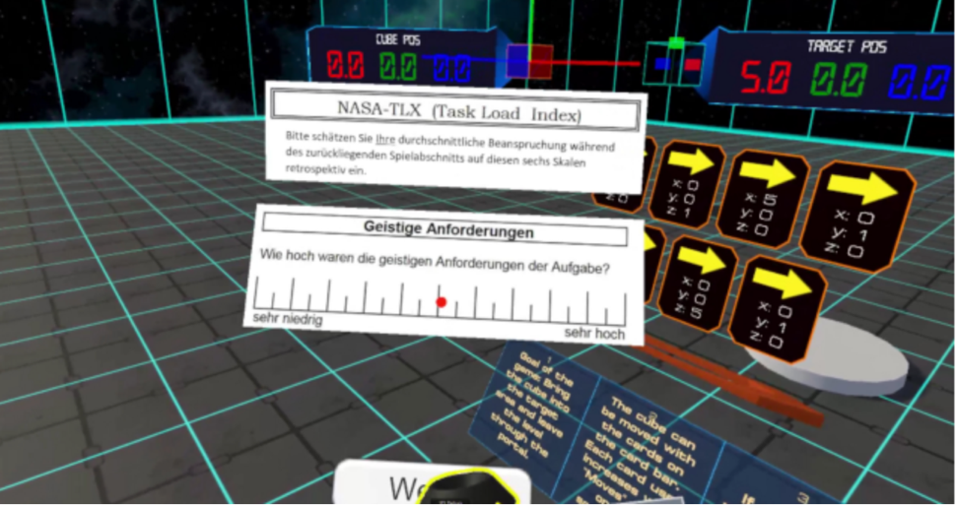

# Discussions

**Xingbo**

# Actions

1. **Toolkit developing.**
   1. Reconstruct and optimize the UI.
   2. Complete function the toolkit can import the csv/xml file.
   3. Build the demo questionnaire form and demo scene.

# Next meeting

9:30 – 10:30am, Monday, 25 Oct 2021

**V5.0**

Minutes taker: Xingbo Wei

Date: 18 October 2021

## For approval

Yue Li

18 October 2021